Arizona is one of 23 states plus the District of Columbia suing the U.S. Department of Health and Human Services and Secretary Robert F. Kennedy Jr. over its "reckless" decision to terminate billions in public health grants.
In Arizona, the state health department announced March 28 that the loss of federal public health grant money would be $190 million.
Arizona Attorney General Kris Mayes' office on April 1 said total loss is higher than that, however, at least $239 million, because Arizona's Medicaid agency lost nearly $50 million in federal grants as part of the cuts. Nationally, $11 billion in grants allocated during the COVID-19 pandemic have been cut, the lawsuit says.
The termination of the federal contract money in Arizona is expected to cause job losses, prevent needed upgrades to the state's disease surveillance system, hinder health insurance enrollment assistance and stop some health education programs, including vaccine outreach.
Mayes and other attorneys general want a temporary restraining order to invalidate the grant cancellations, arguing that the action violates the federal Administrative Procedure Act. They filed the lawsuit April 1 in the U.S. District Court in Rhode Island. Among the other states included as plaintiffs in the lawsuit are California, New Mexico, Minnesota, Rhode Island, Washington and Massachusetts.
The defendants in the lawsuit are the U.S. Department of Health and Human Services, HHS, and Kennedy, who is the HHS Secretary. A news release from Mayes' office says the "stop work" order on the public health grants to states had no "legally valid explanation" and has caused chaos in a number of state public health programs.
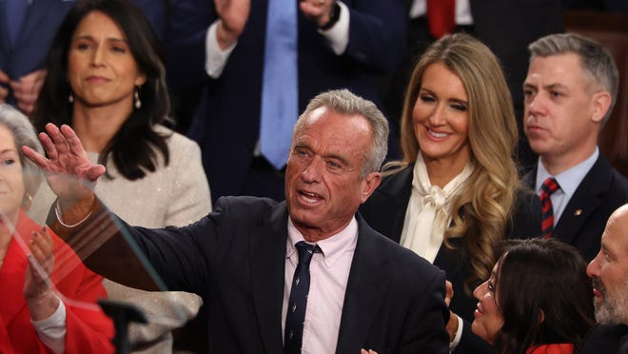

“I cannot overstate how reckless and illegal these cuts are,” Mayes said in a written statement. “By slashing these grants, the Trump administration has launched an all-out attack on Arizona’s public health system − harming the entire state, but hitting rural communities the hardest."
Grants for rural health departments and other organizations that support telehealth services are getting cut, as are mobile vaccine clinics and other community vaccination efforts, according to Mayes. The cuts came from two HHS agencies: the Centers for Disease Control and Prevention, CDC, and the Substance Abuse and Mental Health Services Administration, SAMHSA.
Your subscription, your way
Managing your subscription has never been easier. Pause delivery, update your credit card and more online.
Manage Subscription
"The HHS cuts threaten the urgent public health needs of states around the country at a time when emerging disease threats — such as measles and bird flu — are on the rise," the news release states.
“With this single threat, Secretary Kennedy has all but ensured that more Arizonans will get sick and die the next time we suffer an infectious disease outbreak, or god forbid, another pandemic."
Separately from terminating the public health funding, Kennedy is downsizing HHS from 82,000 full-time employees to 62,000, or nearly 25% of the workforce.
In an interview with NewsNation about the cuts, Kennedy said the plan does not cut scientists or frontline workers.
"We’re cutting administrators," Kennedy said. “The agency org chart when I arrived was incomprehensible. There was no chain of command, there were people operating in all these different silos and fiefdoms.”
Thousands of Arizonans join anti-Trump 'Hands Off!' protests across the stateKyrsten Sinema's employer had prior links to PTSD therapy she now touts at AZ LegislatureMigrant kids in Arizona still receiving legal representation while judge weighs lawsuitHere's what Arizona counties stand to lose from severe federal health funding cutbacks

In the April 1 statement, Mayes pledged to continue holding the Trump administration accountable for what she says are illegal and unconstitutional actions.
As part of that pledge, her office has filed numerous lawsuits against the current administration, It also launched a web page to collect reports of Social Security issues, including any disruptions to their earned benefits.
"At this time, Arizonans should be receiving their Social Security cheques as normal, but we are starting to see reports of disruptions," a statement from Mayes' office says.
Arizonans experiencing a disruption in the social security payments or services may report it to: https://www.azag.gov/socialsecurity.

